2024 Ranger Add Sheet
Floating Economy Nets
This new series of nets float! They feature an all blue anodized hoop, octagon handle, and foam hand grip. There is a choice of a rubber coated flat bottom net, now with larger 1” mesh, or a clear completely rubber net.

Model | Hoop | Handle | Net
920F | 20” x 24” | 36” octagon | 24” deep rubber coated nylon flat bottom net, 1” mesh
920FT | 20” x 24” | 43" to 72" octagon telescopic handle | 24” deep rubber coated nylon flat bottom net, 1” mesh
920FR | 20” x 24” | 36” octagon | 19" deep clear rubber net
920FTR | 20” x 24” | 43" to 72" octagon telescopic handle | 19" deep clear rubber net

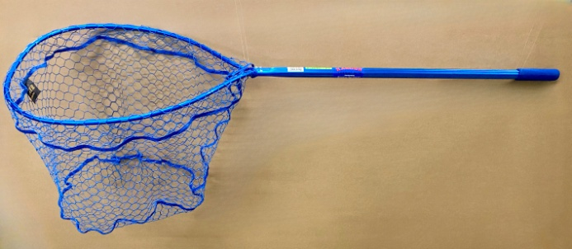 | 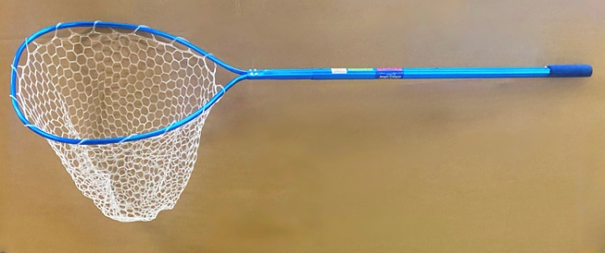

Catch & Release Rubber Net
The new model 2243R is a larger version of our popular model 2242R. It features a clear completely rubber net, unbreakable nylon handle, and a lanyard with a snap.

Model | Hoop | Handle | Net
2243R | 14” x 18” | 8” nylon | 15” deep clear rubber net

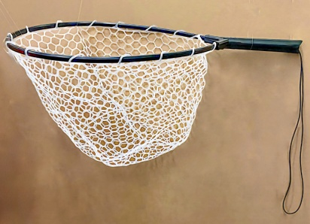
*We now have a 16” deep rubber net that fits our 25” x 25” hoop size (models 491, 978, 9788, 991), which comes in black or clear.

